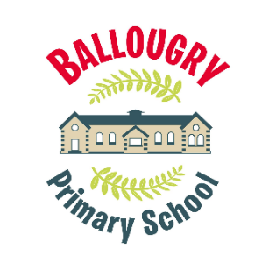
Weekly Newsletter


- Interactive jazz concert P1 to P7

- PE- Primary 1 to 7
- Primary 5,6 & 7 (Spanish with Mrs Abbott)


- School show practice
- After school sports club 3pm to 4pm



Dates for diaries
Do This In Memory Mass - 26th April @ 6pm St Columba’s Church- Long Tower
First communion - Thursday 21st May@ 1.30pm.
May bank holiday- Monday 4th May

- Primary 4/5 (Spanish with Mrs Abbott)

- Friendship circle after school club
3pm to 4pm

Breakfast club- daily from 8.15am- Please book on Parent Pay.
Dinner Service – Week 3. Please try to book by 9pm on Sunday.
After school club-2-3pm and 3pm-4pm daily Mon-Thurs- book on Parent Pay.

